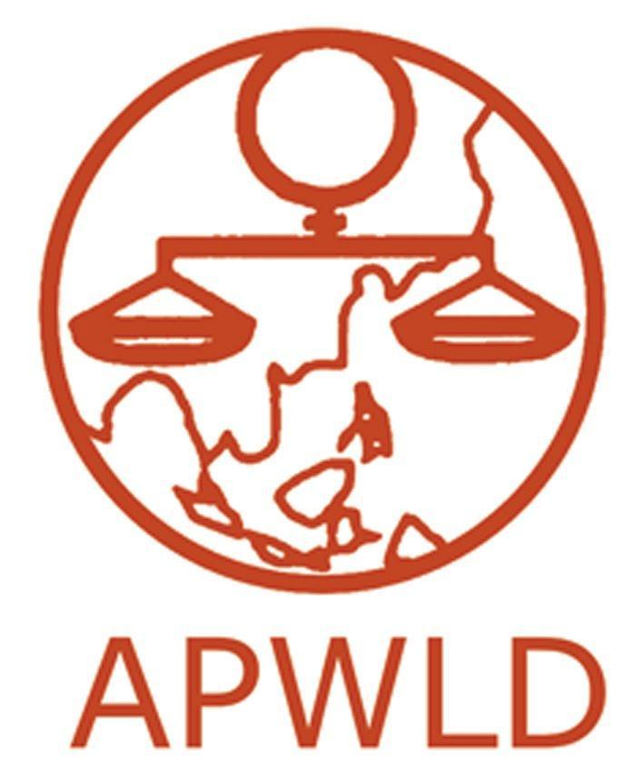
Asia Pacific Forum on Women, Law and Development
NGO in consultative status with the Economic and Social Council of the United Nations

Feminist Participatory Action Research (FPAR) 2023-2025

“Feminist Food Sovereignty: Women reclaiming control and fighting back
against the corporatisation of food”

APPLICATION FORM

Contact Information
Name of organisation
Office address
Official organisation email
office telephone & fax
Contact person:
Name
Email Address
Phone Number | (please identify whether you use the phone number for Whatsapp, Line, Viber or other messenger applications)
Website and Social Media Accounts (if applicable) | (e.g. Facebook, Twitter, Instagram, etc)

Organisational background

- Brief profile of your organisation (Max. 500 words)

- Mission and Goals
- Thematic areas of focus (e.g., land rights, political participation, etc)
- Target sectors / groups and beneficiaries
- Geographical areas of work
- Organisational structure, including number of staff and positions
- List of membership and/or network with brief description
- Year established

- Please share your strategic/activity plan for 2023-2025, including the major focus and events you expect to conduct (max 500 words).

- Does your organisation have experience in research and/or documenting food sovereignty? If yes, what was the focus of the research/documentation? If yes, please provide brief description/s on the research work. What methods have you used? How were the results used to address the violations? (Max. 300 words)

- Share one or two initiatives / successes / strategies that contributed to the improvement of the situation of women and the communities that you have worked with (Max. 400 words)

Focus of the FPAR, Objectives and Expected Results

In reference to the concept note on the FPAR on Feminist Food Sovereignty that we have provided:

- How does your organisation view feminist food sovereignty? (Max. 300 words)

- What are your overall objectives in this FPAR? (Max. 200 words)

- Which issues do you plan to focus on if you are selected to be part of this FPAR and why? How do they affect the situation of women and the community/ies particularly their human rights and food sovereignty? (200 words)

- Identify the group of women/community/local group/movement you intend to work with. Describe their situation. Have you worked with them before? If yes, in what capacity have you worked with them and for how long? (Max. 300 words)

- In relation to your objectives and situation, briefly describe the expected results that you foresee. (200 words)

- How could this FPAR support your organisation or network to build movements of women? (300 words)

- How else would your organisation or network benefit from being able to employ a young woman to be part of this FPAR? (300 words)

Budget

Please include the budget for implementation of research, including the appointment of a young woman researcher until the end of the FPAR cycle. Please also include the costs of:

- Salary and related costs to employ a staff member (i.e. young woman researcher)
- Communication costs (telephone, fax, internet etc.)
- Local travel costs
- Events related to the research

Please note that the FPAR budget will not support costs related to institutional support, such as office rent, payment for electricity/water bills, purchasing of assets and equipment, construction costs and humanitarian aid. Do not include costs to attend the regional capacity building workshops organised by APWLD.

Provide a website link as a reference to the estimated exchange rate and date (National Bank, Official Currency Converter)_______________________________________

Please follow the budget template below (feel free to add rows):

Description | Unit | Price /unit | Total amount in local currency | Mean of verification | % out of the total budget | total in USD
1. Researcher salary 16 months (including benefits) |  |  |  | Contract or payment slip /month
2. Local travel and accommodation, meals related to research |  |  |  | Receipts
3. Stationery include printing and photocopying |  |  |  | Receipts
4. Communication costs (including internet) |  |  |  | Internet card, tel card
5. Meeting / events related to research |  |  |  | Receipts
6. Contribution to Community towards research |  |  |  | Acknowledge received of fund
7. FPAR documentation, film and translation  (This is not hiring someone to write the report) |  |  |  | Contract
8. Others / Miscellaneous: please specify |  |  |  | Receipts
Total

Please note that the budget for APWLD support to each research country is USD 14,000 maximum.

Reference:

- Has your organisation participated in any APWLD organised activities?
- Do you know any APWLD members in your country?
- Is your organisation part of regional or international networks?
- Referees (please attach letter of recommendation separately) (at least 2)

Please send completed forms by Wednesday, 19 July 2023
to eloisa@apwld.org and tasmiah@apwld.org

