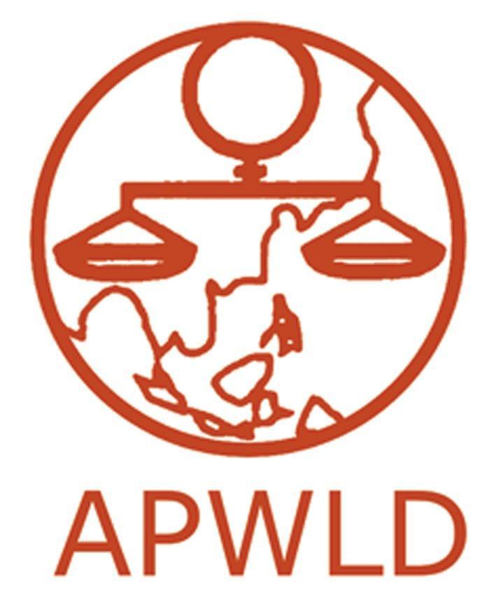
Asia Pacific Forum on Women, Law and Development
NGO in consultative status with the Economic and Social Council of the United Nations

Feminist Rapid Response Research on COVID-19:
“Our Voice, Our Stories, Our Demand for Development Justice”

APPLICATION FORM

Contact Information
Name of organisation
Office address
Official organisation email
office telephone & fax
Contact person:
Name
Email Address
Phone Number | (please identify whether you use the phone number for Whatsapp, Line, Viber or other messenger applications)
Website and Social Media Accounts (if applicable) | (e.g. facebook, twitter, Instagram, etc)

Organisational background

- Brief profile of your organisation (max 500 words)
  - Mission and Goals
  - Thematic areas of focus (e.g. violence against women, labour rights, climate justice, etc.)
  - Target sectors / groups and constituencies
  - Geographical areas of work (local, national or regional)
  - Organisational structure, including number of staff and positions
  - List of membership and/or network with brief description
  - Year established

- What COVID-19 response efforts has your organisation been working on? Please briefly describe them. (max 500 words)

Objectives, Focus of the documentation, and Expected Results

In reference to the concept note of the FRRR on COVID-19 that we have provided:

- What are your overall objectives and specific objectives in this FRRR? (max 200 words)
- Identify the group of women/community/local group/movement you have been and intend to continue working with as part of this FRRR. How will this programme be relevant to them? Describe your past/existing engagement with them. (max 300 words)
- In relation to your objectives and situation, please briefly describe the expected results that you foresee. (max 200 words)

Budget

Please include the budget for implementation of FRRR. Please also include the costs of:
- Communication costs (telephone, fax, internet etc.)
- Local travel costs
- Others (Important note: costs related to institutional support, purchasing of assets and equipment will not be covered)

(Do not include costs to attend the capacity building workshops organised by APWLD).

Please follow the standard budget format below:

Description | Unit | Price /unit | Total amount in local currency | Mean of verification | % | total in USD
1. Local travel and accommodation, meals related to FRRR |  |  |  | Receipts
2. Stationery include printing and photocopying |  |  |  | Receipts
3. Communication costs (including internet) |  |  |  | Internet card, tel card
4. Meeting / events related to research |  |  |  | Receipts
5. Contribution to Community (including direct support as per the communities’ needs, e.g. food, PPE, etc.)  Note. This budget item shall not exceed 40% of the overall budget; and APWLD’s sub-grant cannot be used for cash disbursement to the community. |  |  |  | Acknowledge received of fund
6. Documentation & translation  (this is not hiring someone to write the report) |  |  |  | Contract
7. Others / Miscellaneous : please specify |  |  |  | Receipts
Total

Please note that the budget for APWLD support to each research country is USD 5,000 maximum.

Please share where you heard about the Call for Application:

☐ Facebook
☐ Twitter
☐ Instagram
☐ APWLD Website
☐ APWLD Members Listserv
☐ APWLD Newsletter
☐ Other, please specify

Signed by (name of the organisational representative):

Date:

(By signing off this application form, the applying organisation commits to continue working with APWLD throughout the entire FRRR process if selected).

Please send completed forms by 28 September 2020 to
covid19@apwld.org or fax to +66(0)53 280 847
(Please use the subject line: APWLD Application_FRRR COVID-19_name of your organisation)

