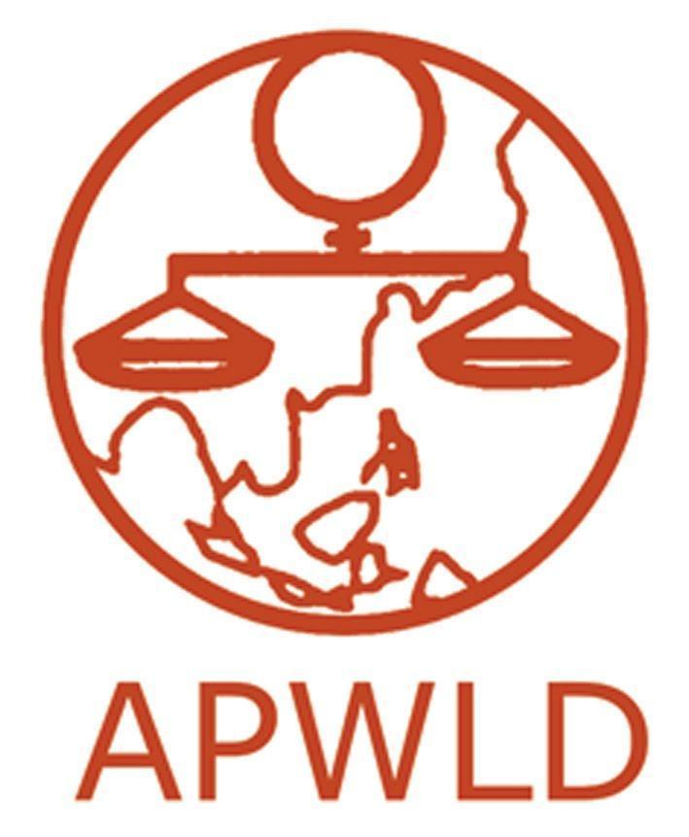
Asia Pacific Forum on Women, Law and Development
NGO in consultative status with the Economic and Social Council of the United Nations

South-South Placement:

Young Women’s Leadership Programme

Application Form

Contact Information
Name of Applicant
Date of Birth and Age
Gender identity | - Female  - Trans female/Trans woman  - Gender non-conforming/Gender queer/Non-binary  - Others  - Prefer not to say
Country
E-mail
Mobile Number  Available on Whatsapp, Signal or other messaging platform? | - Whatsapp  - Signal  - Others:
Skype ID
Endorsing APWLD Member Organisation
Office Address
Name and email of Reference in Endorsing Organisation

- Briefly introduce yourself, clearly outlining your experience or familiarity in women’s rights, human rights, climate justice, environment justice, gender or economic justice at local, national and/or regional levels. , etc.)

- Why would you like to participate in the South-South Placement: Young Women’s Leadership Programme? Why is working at APWLD important to you being part of the APWLD Secretariat? What do you want to achieve during your South-South placement with us?
- Please indicate how long have you been involved with the endorsing APWLD Member Organisation and in what capacity? If you are currently working with them, please describe your current role and responsibilities.

- Please share (maximum of 3) key ways you have been able to contribute to movement building and activism within the endorsing APWLD Member organisation. What roles, tasks and responsibilities did you fulfill in ensuring that targets and objectives for these were achieved?

- Please describe with examples your skills in: (Check all that apply)
Example: Research: I am knowledgeable with Participatory Action Research methodology and have worked as a grassroots community organiser. I have also done desk research on attacks on WHRDs and policies to combat VAW in three countries (India, Nepal and Bangladesh) in South Asia.

☐ Technical knowledge (in either/and women’s rights, human rights, environment/climate justice, etc) :

☐ Research:

☐ Oral, interpersonal & written Communication:

☐ Advocacy and Policy Analysis:

☐ Capacity-building/training:

☐ Event Organising, networking and mobilisation:

☐ Others:

- What skills would you like to develop during your participation in the South-South Placement: Young Women’s Leadership Programme?

- How do you think the endorsing APWLD Member organisation will benefit from your participation in this programme? How do you plan to integrate the skills and knowledge that you have learned at APWLD to your endorsing organisation after you have completed the placement?

- Have you ever participated in any APWLD programmes? Please specify which programmes and when?

- If you are offered the South-South Placement, how soon can you be in Chiang Mai, Thailand? Do you have any upcoming obligations, dates or engagements on the calendar that should be considered?

Commitment of the NGO/Institution
Please provide an endorsement letter from an APWLD member organisation supporting your participation. The endorsement should reflect the below: :
- The organisation/institution should certify that the person recommended has worked in the area of women’s human rights and is committed to the objectives and responsibilities of the South-South Placement: Young Women’s Leadership Programme.
- How will the participation of the applicant to South-South Placement: Young Women’s Leadership Programme benefit your organisation?
- Please indicate that your organisation is willing and able to provide a contract for the applicant for double the period of time they were hosted at APWLD.

Please submit the COMPLETED Application form and include:

- Curriculum Vitae or Resume
- Sample of research or written work
- Endorsement letter from APWLD member organisation

Please send your applications to:

Marion Cabrera, Executive and Human Resource Officer; email: recruitment@apwld.org
with a Subject Line “South South Leadership Application for Climate Justice Programme”
DEADLINE for application is 13th March 2020
Please note incomplete or late applications will not be considered

