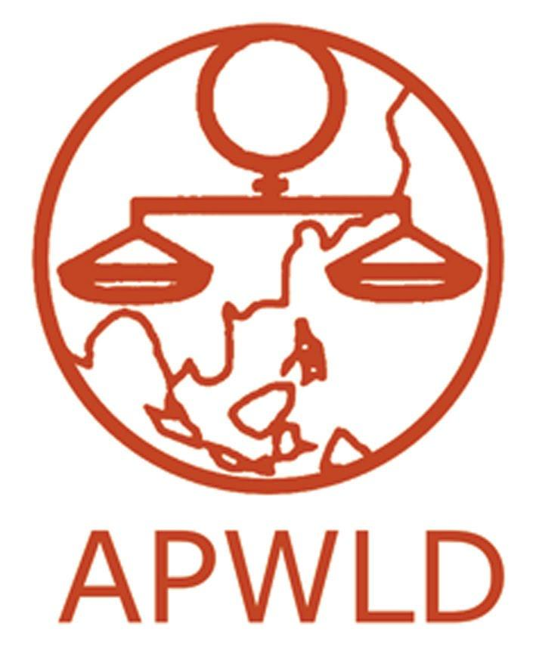
Asia Pacific Forum on Women, Law and Development
NGO in special consultative status with the Economic and Social Council of the United Nations

5th “Women Leading, Women Organising’ Regional Training
14-19 December 2019
Penang, Malaysia

APPLICATION FORM

- Contact Information

First Name: |  | Last Name:
Age: |  | Country:
Organisation/
Union Name:
Position/ Title:
Postal Address:
Telephone | Mobile: |  | Office:
E-mail

- Information of the Applicant and Organisation

- Please provide information about your organisation:
- Type/Sector of union (for example, domestic workers, garment etc) : ___
- Number of union membership: _________ Total of which ______ No. of women
- Established since (date): ____ month___ year

- Please briefly describe your major roles in your organisation/union?

- How long have you been involved with this organisation/union?
  - _______ years ____ months

- Have you participated in any previous trade union training? If yes, please give a brief description about the training (location, organizers, duration, contents. Etc).

- Have you ever been a participant in any activity conducted by APWLD in the past?

- Yes____ No____

If yes, give provide following details (precise details not required. Please add more rows as needed):
Name/Kind of the activity | When | Where | How was the activity useful for your present line of work?

- Please explain why you want to participate in this training and how you think this training will help in your work (max 200 words)

- Understanding level: Women Migrant Workers’ Critical Issues
- What are the critical issues affecting women workers in your country and sub-region? Please provide examples. (max 100 words)

- Please share the key issues and challenges that you and/or your organisation face, preferably with examples. (max 100 words)

- What roles do you think workers organisation/unions can potentially play in challenging and shaping the national, regional and international political agenda to ensure women workers’ representation and voice? (max 100 words)

- Proficiency in English and Translation support

- Please rate your proficiency in the English language:
Rating  Put ‘X’ as applicable | 5: Very Good | 4: Good | 3: Fair | 2: Poor | 1: Very Poor
Understanding
Reading
Writing
Speaking

- Will you be needing help in translation from English to your language and vice versa?
Yes ( ) No ( )

- If needs be, are you willing and able to translate for another participant from your country?
Yes ( ) No ( )

- What other language(s) do you speak from Asia Pacific, if needs arise for translation to other fellow participants?

  - Fluent:
  - Other Basic conversational:

- Guide for endorsement letter
We will need an endorsement letter from an organisation/union supporting your participation addressing the following matters:

- The organisation/institution should certify that the applicant has the potential to be a trade union leader within the organisation and is committed to applying the core learning points of the training in her future work.

- Why the organisation would like to nominate the applicant and how they expect the training to benefit their organisation.

Please answer ALL questions and use additional sheets if required.

Please submit the following documents to Ms. Suluck Fai Lamubol at fai@apwld.org
By 31th October 2019
1. Completed application form
2. Your Curriculum Vitae/CV (not more than 2 pages)
3. Endorsement/ recommendation letter from your organisation

Incomplete applications will not be considered
(With either of incomplete/missing Application form, CV or Endorsement letter)

Please note that only selected applicants will be contacted

Asia Pacific Women, Law and Development (APWLD)
PO Box: 189/3 Changklan Road
Amphur Muang
Chiang Mai 50101
Thailand
Tel.: +66-53-284 527/ 284 856 Fax: +66-53-280 847

