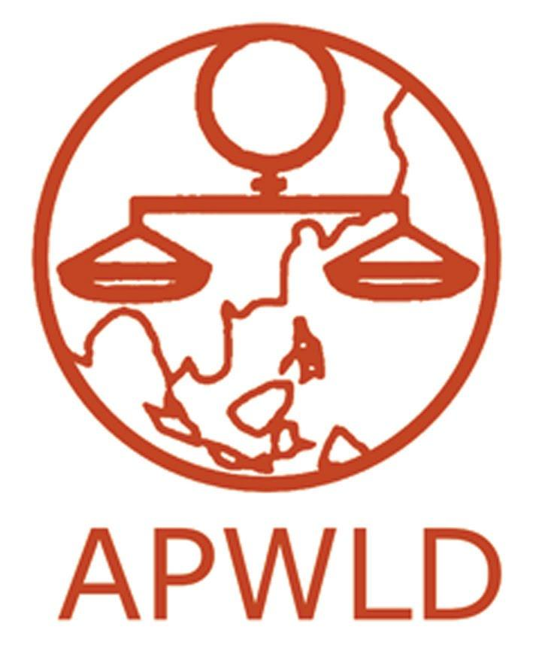
Asia Pacific Forum on Women, Law and Development
NGO in consultative status with the Economic and Social Council of the United Nations

Support to Rural, Indigenous, Migrant, Urban Poor Women’s Movements 2020-2022

Feminist Participatory Action Research (FPAR)
“Amplifying Marginalised Women’s Voices and Strengthening Movements
for Women’s Rights to Peace and Democratic Participation”

APPLICATION FORM

Contact Information
Name of organisation
Office address
Official organisation email
office telephone & fax
Contact person:
Name
Email Address
Phone Number | (please identify whether you use the phone number for Whatsapp, Line, Viber or other messenger applications)
Website and Social Media Accounts (if applicable) | (e.g. facebook, twitter, Instagram, etc)

Organisational background

- Brief profile of your organisation (Max. 500 words)
- Mission and Goals
- Thematic areas of focus (e.g., land rights, political participation, etc)
- Target sectors / groups and beneficiaries
- Geographical areas of work
- Organisational structure, including number of staff and positions
- List of membership and/or network with brief description
- Year established

- Please share your strategic/activity plan for 2020-2022, including the major focus and events you expect to conduct.

- Does your organisation have experience in research and/or documenting human rights violations? If yes, what was the focus of the research/documentation? What methods have you used? How were the results used to address the violations? (Max. 300 words)

- Does your organisation have experience in research and/or documenting specifically on women’s rights to peace and democratic participation? If yes, please provide brief description/s on the research work. (Max. 300 words)

- Share one or two initiatives / successes / strategies that contributed to the improvement of the situation of women and the communities that you have worked with ( Max. 400 words)

Focus of the FPAR, Objectives and Expected Results

In reference to the concept note on the FPAR on Women’s Rights to Peace and Democratic Participation that we have provided:

- How does your organisation view women’s rights to peace and democratic participation? (Max. 300 words)

- What are your overall objectives and specific objectives in this FPAR? (Max. 200 words)

- Which area of focus does your organisation intend to work on if you are selected to be part of this FPAR? What is the relevance to the improvement of the situation of women and the community/ies in this FPAR? (200 words)

- Identify the group of women/community/local group/movement you intend to work with. Describe their situation. Have you worked with them before? If yes, in what capacity have you worked with them and for how long? (Max. 300 words)

- In relation to your objectives and situation, briefly describe the expected results that you foresee? (200 words)

- How could this FPAR support your organisation or network to build movements of women? (300 words)

- How else would your organisation or network benefit from being able to employ a young woman to be part of this FPAR? (300 words)

Budget

Please include the budget for implementation of research, including the appointment of a young woman researcher until the end of the FPAR cycle. Please also include the costs of:

- Salary and related costs to employ a graduate level staff member
- On costs (telephone, fax, internet etc.)
- Local travel costs
- Others (Important note: costs related to institutional support, purchasing of assets and equipment will not be covered)

(Do not include costs to attend the capacity building workshops organised by APWLD).

Please follow the standard budget format below:

Description | Unit | Price /unit | Total amount in local currency | Mean of verification | % | total in USD
1. Researcher salary 15 months (including benefits) |  |  |  | Contract or payment slip /month
2. Local travel and accommodation, meals related to research |  |  |  | Receipts
3. Stationery include printing and photocopying |  |  |  | Receipts
4. Communication costs (including internet) |  |  |  | Internet card, tel card
5. Meeting / events related to research |  |  |  | Receipts
6. Contribution to Community towards research |  |  |  | Acknowledge received of fund
7. FPAR documentation, film & translation  (this is not hiring someone to write the report) |  |  |  | Contract
8. Others / Miscellaneous : please specify |  |  |  | Receipts
Total

Please note that the budget for APWLD support to each research country is USD 13,000 maximum.

Reference:

- Have you/your organisation participated in any APWLD organised activities?
- Do you know any APWLD members in your country?
- Is your organisation part of regional or international networks?
- Referees (please attach letter of recommendation separately) (at least 2)

Please send completed forms by Monday, 7 September 2020 to
marjo@apwld.org and patricia@apwld.org or fax to +66(0)53 280 847
(Please use the subject line: APWLD Application - BOOM Peace FPAR 2020-2022_name of your organisation)

