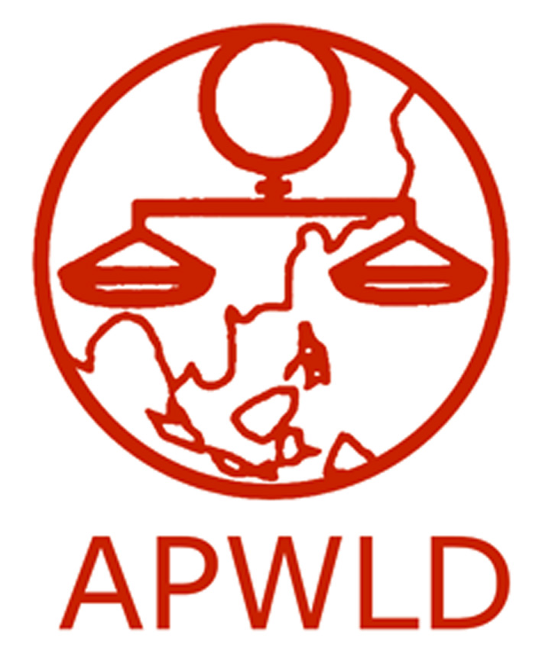
Asia Pacific Forum on Women, Law and Development
NGO in consultative status with the Economic and Social Council of the United Nations

South-South Placement: Young Women’s Leadership Programme
Application Form

Contact Information
Name of Applicant
Date of Birth and Age
Country
E-mail
Telephone Number
Skype ID
Endorsing APWLD Member Organisation
Office Address
Name and email of Reference in Endorsing Organisation

- Briefly introduce yourself, clearly describing your involvement in country specific issues (ex: land rights, economic justice, VAW, WHRD etc. or skills (ex: video editing, research, graphic design, monitoring and evaluation, etc.) Explain why you would like to participate in the South-South Placement: Young Women’s Leadership Programme? Why is working at APWLD important to you?

- Please indicate how long you have been involved with the endorsing organisation and in what capacity? If you are currently working with them, please describe your current role and responsibilities.

- Please describe your familiarity with the Feminist Development Justice programme and development policy. Please also give us a background of relevant work experience in sustainable development and women’s rights.

- Please check the following areas which you have a background in and please explain in what capacity? (Check all that apply)
Example: Research: I am knowledgeable with Participatory Action Research methodology and have worked as a researcher with local communities on the issue of Decent Work and Living Wage. I have also done desk research on national labour laws and policies for three countries (India, Nepal and Bangladesh) in South Asia.

Capacity-building:

Research:

Communications:

Advocacy and Policy Analysis:

Event Organising and mobilisation:

- What do you hope to achieve and what skills would you like to develop during your participation in the South-South Placement: Young Women’s Leadership Programme?

- How do you think your endorsing organisation will benefit from your participation in this programme? How do you plan to integrate the skills and knowledge that you have learned at APWLD to your endorsing organisation after you have completed the placement?

- Have you ever participated in any APWLD programs? Please specify which programs and when?

- If you are offered the South-South Placement, how soon can you be in Chiang Mai, Thailand? Do you have any upcoming obligations, dates or engagements on the calendar that should be considered?

Commitment of the NGO/Institution
We will need an endorsement letter from an APWLD member organisation supporting your participation. May we ask that the following be addressed in their endorsement letter for you:
- The organisation/institution should certify that the person recommended has worked in the area of women’s human rights and is committed to the objectives and responsibilities of the South-South Placement: Young Women’s Leadership Program.
- How will the participation of the applicant to South-South Placement: Young Women’s Leadership Program benefit your organisation?
- Please indicate that your organisation is willing and able to provide a contract for the applicant for double the period of time they were hosted at APWLD.
Please answer all questions completely and use additional pages if required.

Please submit the completed form to Leanne Sajor (Leanne@apwld.org) or Fax to 66-(0)53-280-847 along with a copy of the following:
- Your Curriculum Vitae (CV) or Resume
- Endorsement Letter

DEADLINE: Monday, March 14, 2016
Please send in your applications as soon as possible.
INCOMPLETE OR LATE APPLICATIONS WILL NOT BE CONSIDERED

