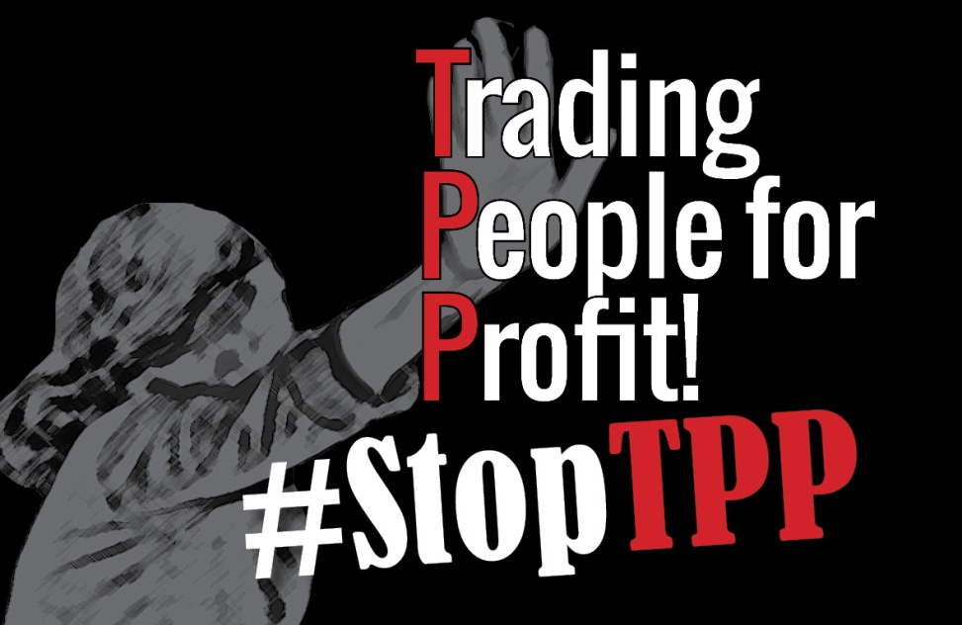

CALL FOR PARTICIPATION: Building Effective Resistance Against the TPP
November 17, 2015
Quezon City, Philippines

Asia- Pacific Resource Network (APRN), Asia-Pacific Mission for Migrants, Pesticide Action Network Asia and the Pacific (PAN-AP) and Asia Pacific Forum on Women, Law and Development (APWLD), Health Alliance for Democracy and Asian Peasant Coalition invite you to take part in a workshop series in building activism against the Trans-Pacific Partnership Agreement.

The workshop will be held at the 3rd International Festival for People’s Rights and Struggles (IFPRS). The IFPRS will be gathering workers, peasants, women, indigenous peoples, migrants, artists and cultural workers, youth and many other sectors and communities from Africa, Asia and the Pacific, Europe, Latin America, Middle East, and North America in the Philippines. It is a space for peoples to share and learn from each other about new and longstanding threats to people’s individual and collective rights. It is an occasion to draw lessons from and celebrate the victories of people’s struggles to claim and assert their rights.

The IFPRS offers a wide range of opportunities for learning and networking with simultaneous forums, workshops, strategy sessions, film showings and exhibits. It is an opportunity to strengthen our movements and collective action. (For more information about the event, please visit https://ifprs.wordpress.com/ and https://www.facebook.com/ifprs2015)

About the TPP workshop:

The Trans-Pacific Partnership Agreement was born out of the APEC meetings in the process of finding a path towards creating the Free Trade Area of Asia Pacific (FTAAP) that aims to further liberalize trade in the region. The APEC meeting in 2011 hosted in Honolulu by US, President Barack Obama and Secretary of State Hillary Clinton left no doubt that the TPP serves as the economic arm of the US geopolitical strategy to maintain its political and economic influence in Asia Pacific by creating a region-wide legal regime that serves the interests of and is enforceable by the US and its corporations.

Four years later, and now with negotiators having reached a final agreement on the Trans-Pacific Partnership Agreement, the APEC Ministerial will be hosted in the Philippines. This is an opportune moment to gather as people’s movements and activists to strengthen our resistance against the rotten deal that will cement corporatocracy.

The TPP and other trade agreements like it will institutionalize inequalities, severely curtail people’s rights and freedoms, and cement corporate rights over national sovereignty and democracy.

The TPP may have been born out of APEC Honolulu but a coordinated, robust, inter-national movement against it will be born at the wake of APEC Manila.

Objectives of the Workshop:
• To understand the geopolitical context and the relationship of the TPP to the APEC.
• To deconstruct and interrogate the content of the final text and its implications.
• To strengthen international solidarity and activism against the TPP.

Programme:

The workshop will be a two-part event, each session consists of two hours.

11:00 – 13:00: Workshop 1
The first session will host a panel of experts that will deconstruct and analyze the final text. Each panelist will be speaking on pressing issues on the Trans-Pacific Partnership Agreement and will also share case studies of effective resistance strategies and disruption techniques to inform the strategic discussion in the following session.

14:00-16:00: Workshop 2
The second session will provide space for participants to work in small issue based group settings according to their issue, geography or organizing strategy. This is an opportunity to work collaboratively and deepen our solidarity work among movements who are already organizing against the TPP. At the end of the session, each group will report their action plans/commitments to the entire group.

This is an open event but would require participants to register.

Please note that costs and arrangements for travel, including visas, accommodation and transportation are the sole responsibility of participants. Individual invitations or other letters will be arranged on a case by case basis, so please register as soon as possible. For any requests or inquiries please email Leanne, leanne@apwld.org

Please fill out the form through the following link by Sunday, 8 November 2015: http://goo.gl/forms/jHLfHtkM8a

You can also send Leanne@apwld.org the completed form below.

Building Effective Resistance Against the TPP
November 17, 2015
Quezon City, Philippines

REGISTRATION FORM

Contact Information
Name of organisation or network
City, Country
Name of participant attending the workshop
Email Address
Telephone
List of names and email addresses of other participants from your organisation or network attending the workshop

Organisational background

- Brief profile of your organisation - (mandate/ focus/ target groups/ geographical area)
- Brief overview of your work on the Trans-Pacific Partnership Agreement and other trade related issues. Please indicate your focus issue or expertise on any of the relevant parts of the TPP.
- Are you part of any coalition, campaign, network, or working group that addresses the Trans-Pacific Partnership Agreement? Please list your affiliations.

Workshop Participation
- Why are you interested in attending the workshop?
- Please share 2 outcomes you would like to get out of the workshop.
- Would you be interested in leading a small working group for the second session? If so, please provide the following:
  - Focus Issue
  - Purpose of the breakout group
  - Your background on the issue (previous or current work)
  - Published material for distribution on the TPP.

Please answer all questions completely and use additional sheets if required. Please submit the completed form along with any special requests or questions you may have to Leanne, Leanne@apwld.org by November 8, 2015

