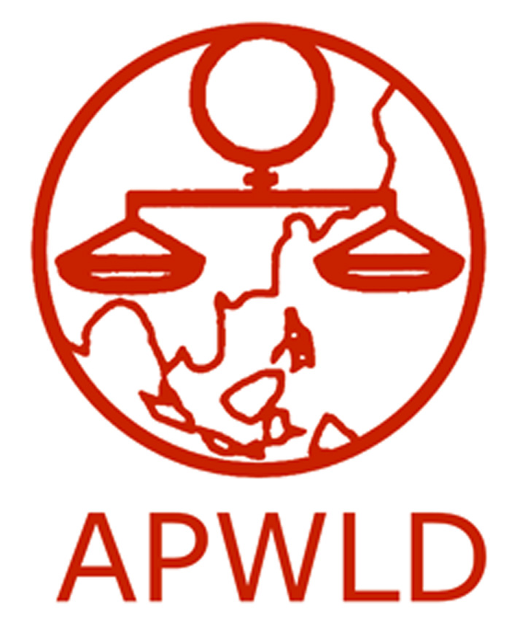
Asia Pacific Forum on Women, Law and Development
NGO in consultative status with the Economic and Social Council of the United Nations

Multi-Country Research: Assessing impacts of policy shifts in relation to implementation
of the ASEAN Community on ASEAN Women
Application Form
Deadline: 17 March

Contact Information
Name of organization
Contact Person and Project coordinator
E-mail address
Work telephone & fax

Organisational background
- Brief profile of your organisation (mandate/ focus/ target groups/ geographical area/ organisational structure and number and profile of staff/ network)
- Does your organisation work on ASEAN issues and/or engage with ASEAN bodies in national and regional levels.

Research Proposal (not more than 2 pages)
The research proposal is expected to cover issues that were identified as the focus areas (please refer to the Request for Research Proposals)
- Title
- Background and Rationale (specific ASEAN legal instruments to be covered and how the research could be used in policymaking and advocacy work)
- Methodological considerations
- Collaborations or additional activities planned as part of the research (if there is any)
- Tentative budget

The ASEAN legal instruments have been agreed upon by country members of ASEAN. These are subjected to ratification and/or acceptance in the country level consistent with the internal procedures of the Member States.

