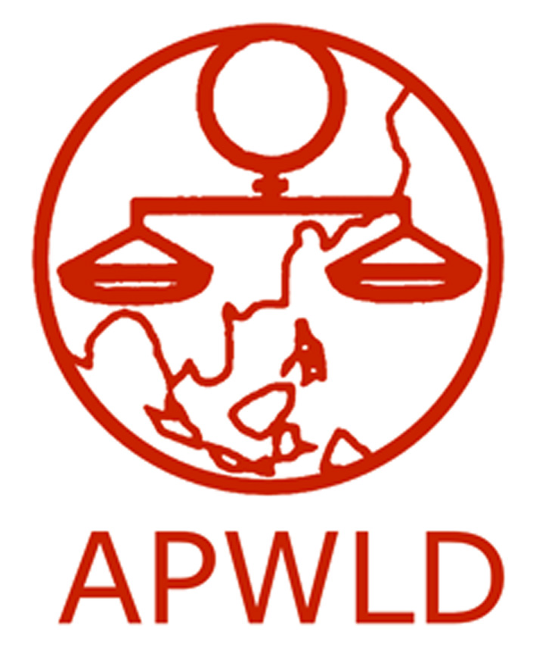
Asia Pacific Forum on Women, Law and Development
NGO in consultative status with the Economic and Social Council of the United Nations

National Advocacy Project 2015
Application Form

Contact Information
Name of organization
Contact Person and Project coordinator
E-mail address
Work telephone & fax

Organisational background
- Brief profile of your organisation (mandate/ focus/ target groups/ geographical area/ organisational structure and number and profile of staff/ network)
- Does your organisation have experience in lobbying with your government? If yes, please provide an example of former advocacy initiatives.

Activity Proposal

- Please give us a background of activities you are currently implementing or have done in the past related to the Post-2015 Sustainable Development Goals and the Beijing Platform for Action.
- What are the 3-5 priority issues you think should be prioritised by your government in the implementation of the Beijing Platform for Action?
- What aspects of the Sustainable Development Goals do you plan to address with your governments? How do you plan to advocate for Development Justice?
- Please provide a detailed explanation of your activity. Please identify which government entities and key stakeholders you plan to engage with.
- Do you plan to collaborate with other organizations for this advocacy activity? If so, please provide a brief profile of the organizations, network or coalition.
- What is your proposed timeline? Please identify a date for your advocacy activity.
- What impact do you expect to achieve on women’s human rights on the national level?
- Approximately USD $3,000 - $3,500 will be allocated for each National Advocacy Activity. Please provide a detailed budget proposal, an example is provided below:
 | Budget Item | Amount | Total
A | Venue
A.1 | Meeting Room
A.2 | Audio and Visual System
B | Accommodation
C | Materials
C.1 | Printing and photocopies
C.2 | Banner
D | Transportation Costs
 | Total Request:

Please submit completed application to Tessa@apwld.org and Leanne@apwld.org by March 6 or fax to 66-(0)53-280-847.

