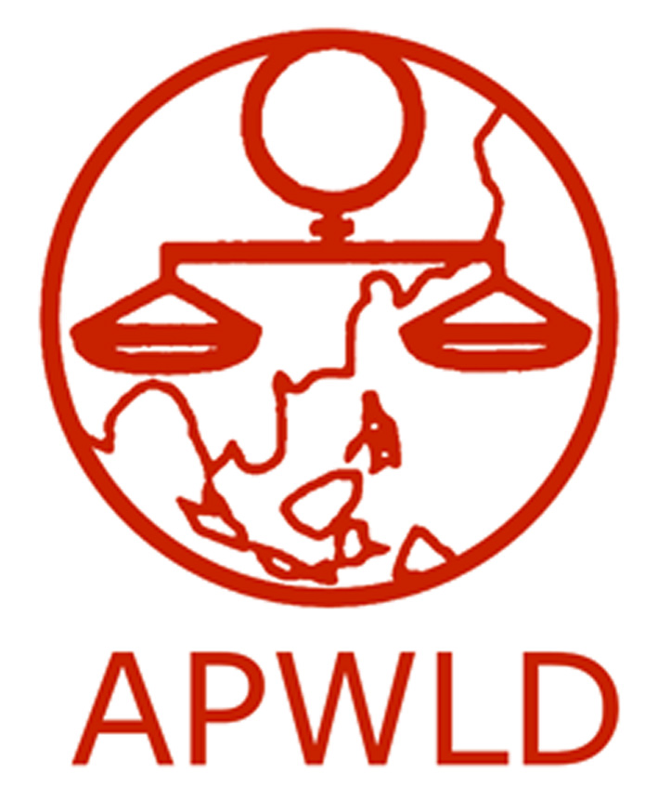
Asia Pacific Forum on Women, Law and Development
NGO in consultative status with the Economic and Social Council of the United Nations

Grants for National Advocacy around Beijing+20 and the Post-2015 Development Agenda:

National Advocacy Project 2015
Application Form

Contact Information
Name of organization
Contact Person and Project coordinator
E-mail address
Organization’s Address
Work telephone & fax

Organisational background
- Brief profile of your organisation (mandate/ focus/ target groups/ geographical area/ organisational structure and number and profile of staff/ network)
- Does your organisation have experience in lobbying with your government? If yes, please provide an example of former advocacy initiatives.

Activity Proposal

- Please give us a background of activities you are currently implementing or have done in the past related to the Post-2015 Sustainable Development Goals and the Beijing Platform for Action.
- What are the 3-5 priority issues you think should be prioritised by your government in the implementation of the Beijing Platform for Action?
- What aspects of the Sustainable Development Goals do you plan to address with your governments? How do you plan to advocate for Development Justice?
- Please provide a detailed explanation of your activity. Please identify which government entities and key stakeholders you plan to engage with.
- Do you plan to collaborate with other organizations for this advocacy activity? If so, please provide a brief profile of the organizations, network or coalition.
- What is your proposed timeline? Please identify a date for your advocacy activity.
- What impact do you expect to achieve on women’s human rights on the national level?
- Approximately USD $3,000 - $3,500 will be allocated for each National Advocacy Activity. Please provide a detailed budget proposal, an example is provided below:
 | Budget Item | Amount | Total
A | Venue
A.1 | Meeting Room
A.2 | Audio and Visual System
B | Accommodation
C | Materials
C.1 | Printing and photocopies
C.2 | Banner
D | Transportation Costs
 | Total Request:

Please submit completed application to Tessa@apwld.org and Leanne@apwld.org by March 24 or fax to 66-(0)53-280-847.

